Software Requirements Specification (SRS) – Wedding Planner

1. Introduction

1.1 Purpose
At Wedding Planner, our mission is to transform your wedding dreams into an extraordinary reality.
"We do more than just plan weddings: - we tell stories, create unforgettable moments, and protect your special love story.

1.2 Scope
Our goal is simple but meaningful:- To create a wedding experience that mirrors your uniqueness, celebrates your love, and goes beyond all your expectations.

1.3 Definitions, Acronyms, and Abbreviations
- Client/User: End-user booking and managing weddings.
- Admin: System administrator with full access.
- Organizer: Manages wedding events and logistics.
- Booking: Reservation of a wedding event/package.
- DFD: Data Flow Diagram.
- ERD: Entity-Relationship Diagram.

2. Overall Description

2.1 Product Perspective
The Wedding Planner is a web-based application, modular in design, with clear separation between user management, booking, event management, and administration.

2.2 Product Functions
- User registration, login, and profile management
- Wedding booking with category selection
- Event, and gallery management for each booking
- Post-wedding activities
- Admin and organizer dashboards

2.3 User Classes and Characteristics
- Client/User: Books and manages their weddings.
- Admin: Manages all users, bookings, categories,

2.4 Operating Environment
- Web browser (Chrome)
- Java backend (Servlets, Hibernate)
- MySQL or compatible RDBMS

2.5 Design and Implementation Constraints
- Follows MVC architecture
- Uses Hibernate ORM for database access
- JSP for frontend

2.6 Assumptions and Dependencies
- Users have internet access
- Admins and organizers are assigned by the system

3. System Features

3.1 User Management
- Register, login, logout
- Profile management
- Access control (admin, client)

3.2 Wedding Booking
- Book a wedding with details (bride, groom, date, category)
- View and manage bookings

3.3 Event Management
- Add, edit, delete events for a booking

3.4 Gallery Management
- Upload and manage images for a booking

3.5 Post-Wedding Activities
- Manage post-wedding events and information

3.6 Admin/Organizer Features
- Manage users, bookings, categories, and events

4. External Interface Requirements

4.1 User Interfaces
- Web-based UI (JSP, HTML, CSS, JS)
- Admin and organizer dashboards

4.2 Hardware Interfaces
- Standard PC

4.3 Software Interfaces
- Java, Hibernate, MySQL

6. Data Model Overview

Main Entities:
- User
- WeddingBook
- WeddingCategory
- Events
- Gallery
- PostWedding
- Organizer

7. Use Case Diagram

Use Cases:
- Register/Login
- Book Services (venue, catering, photography, etc.)
- View/Cancel Bookings
- View Wedding Schedule
- Admin manages users and vendors
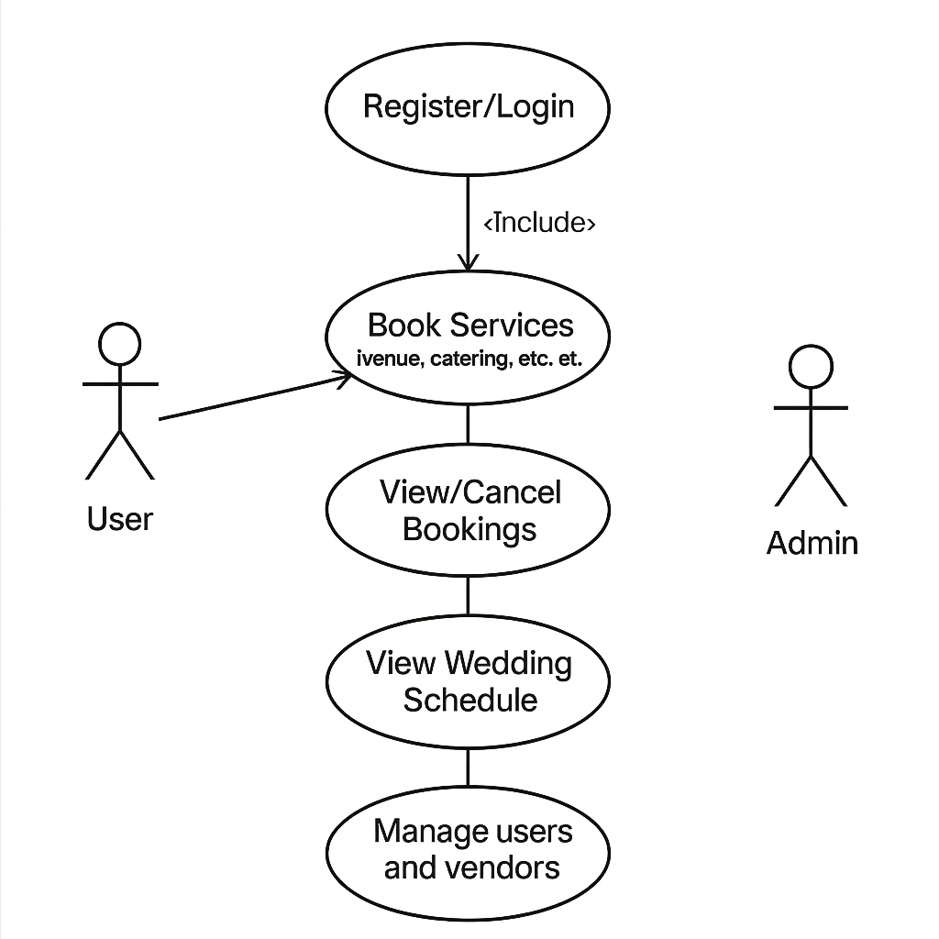

Activity Diagram
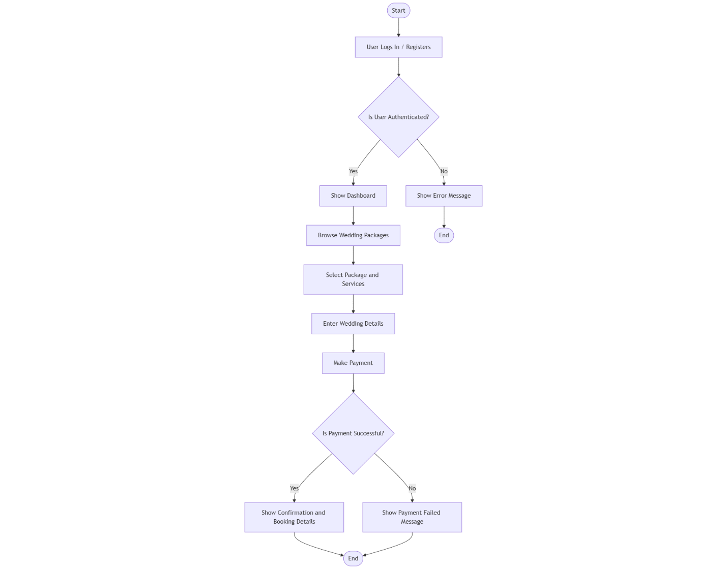

State Machine Diagram

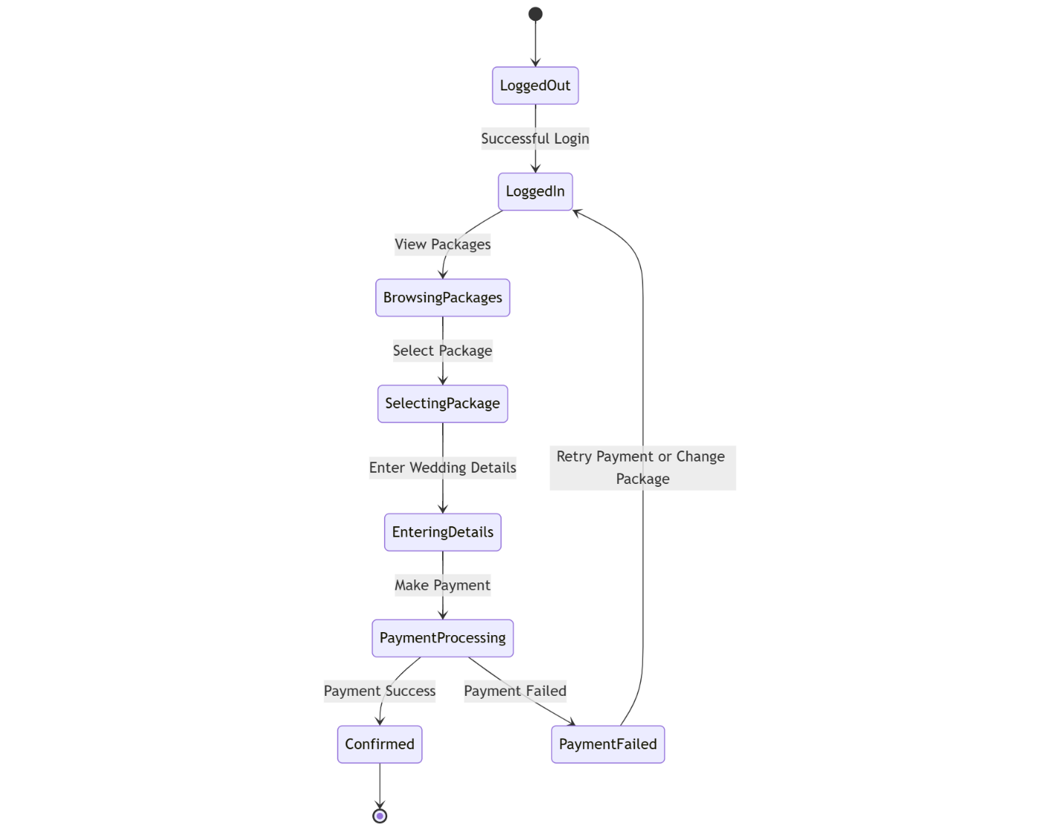

Sequence Diagram
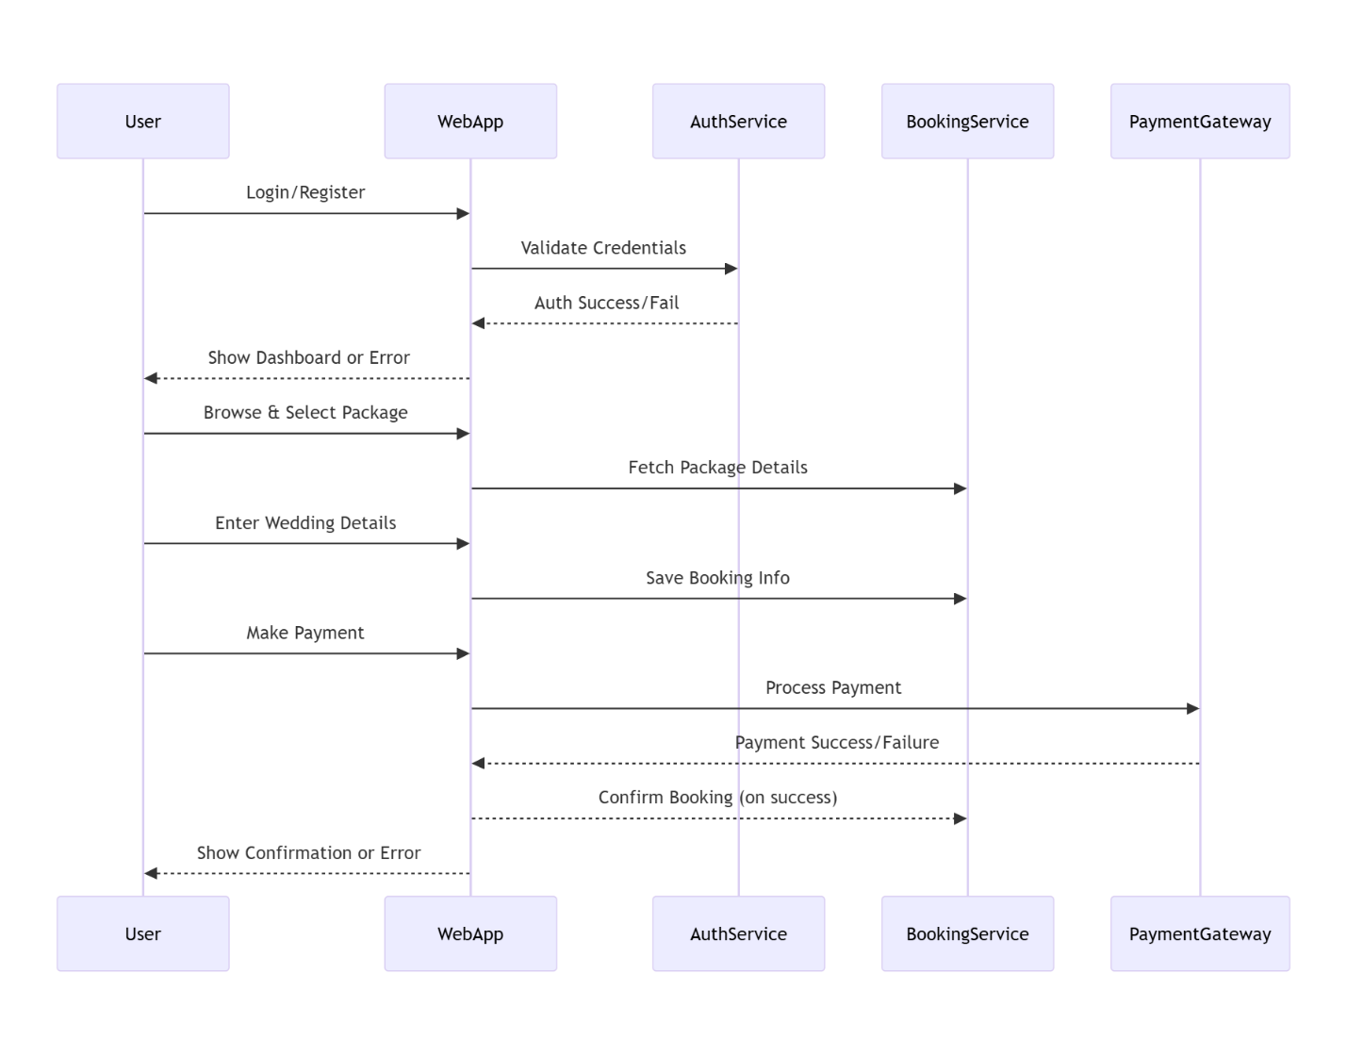

Class Diagram
Classes like:
- User
- Booking
- Payment
- Admin
- 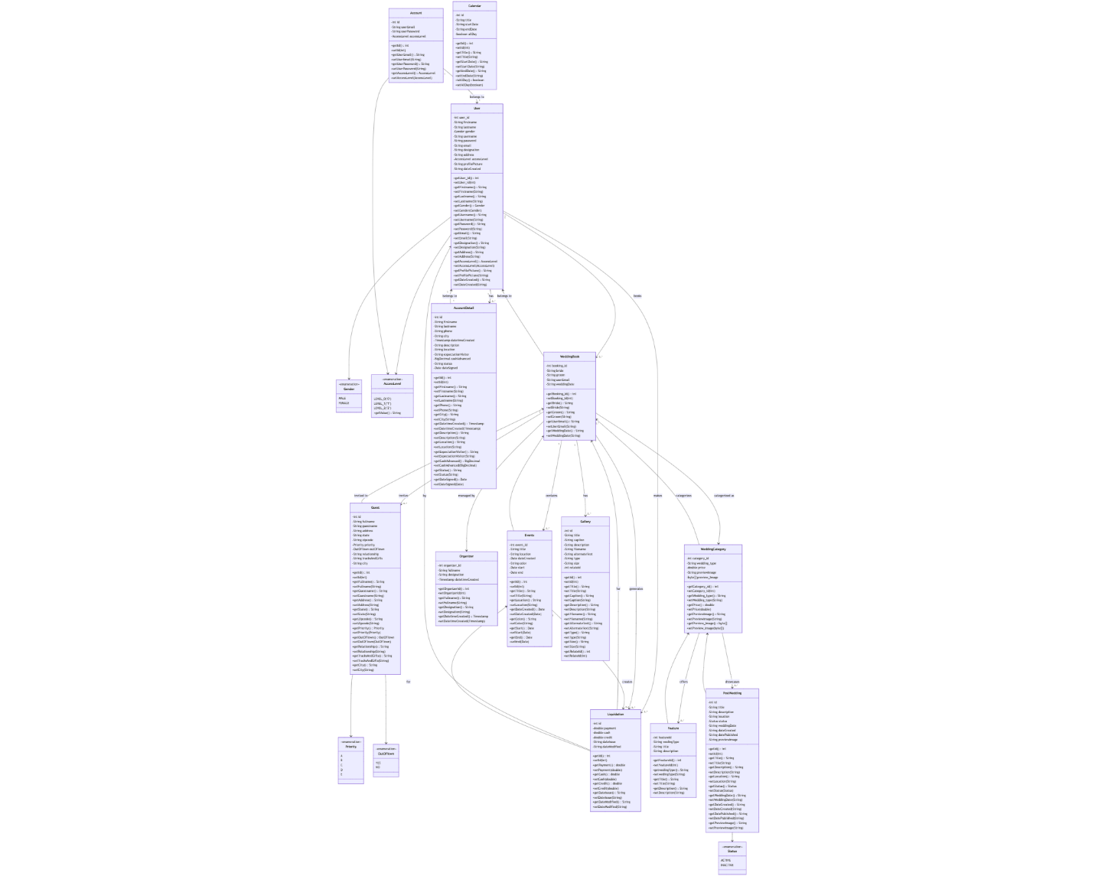

Component Diagram
Shows how different modules like:
- User Interface
- Vendor Service
- Payment Service
- Database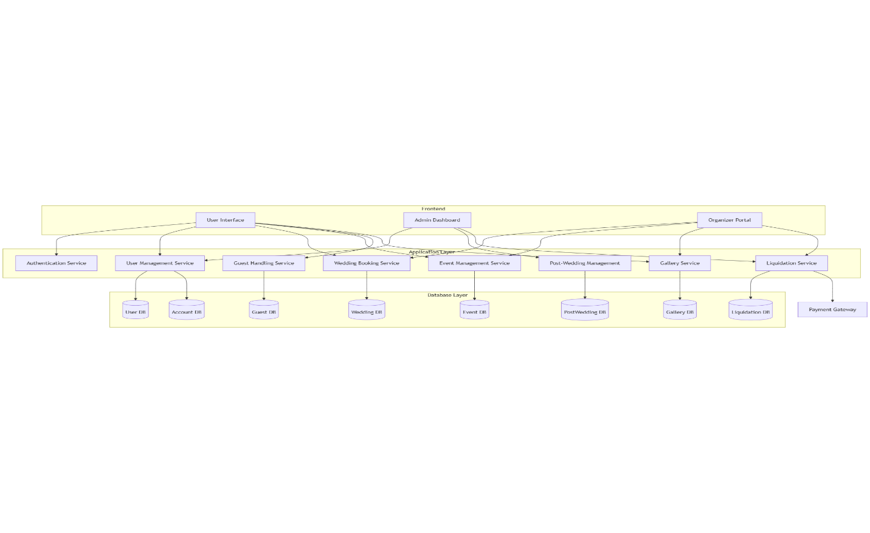

Deployment Diagram
Shows deployment of:
- Web Server
- App Server
- Database Server
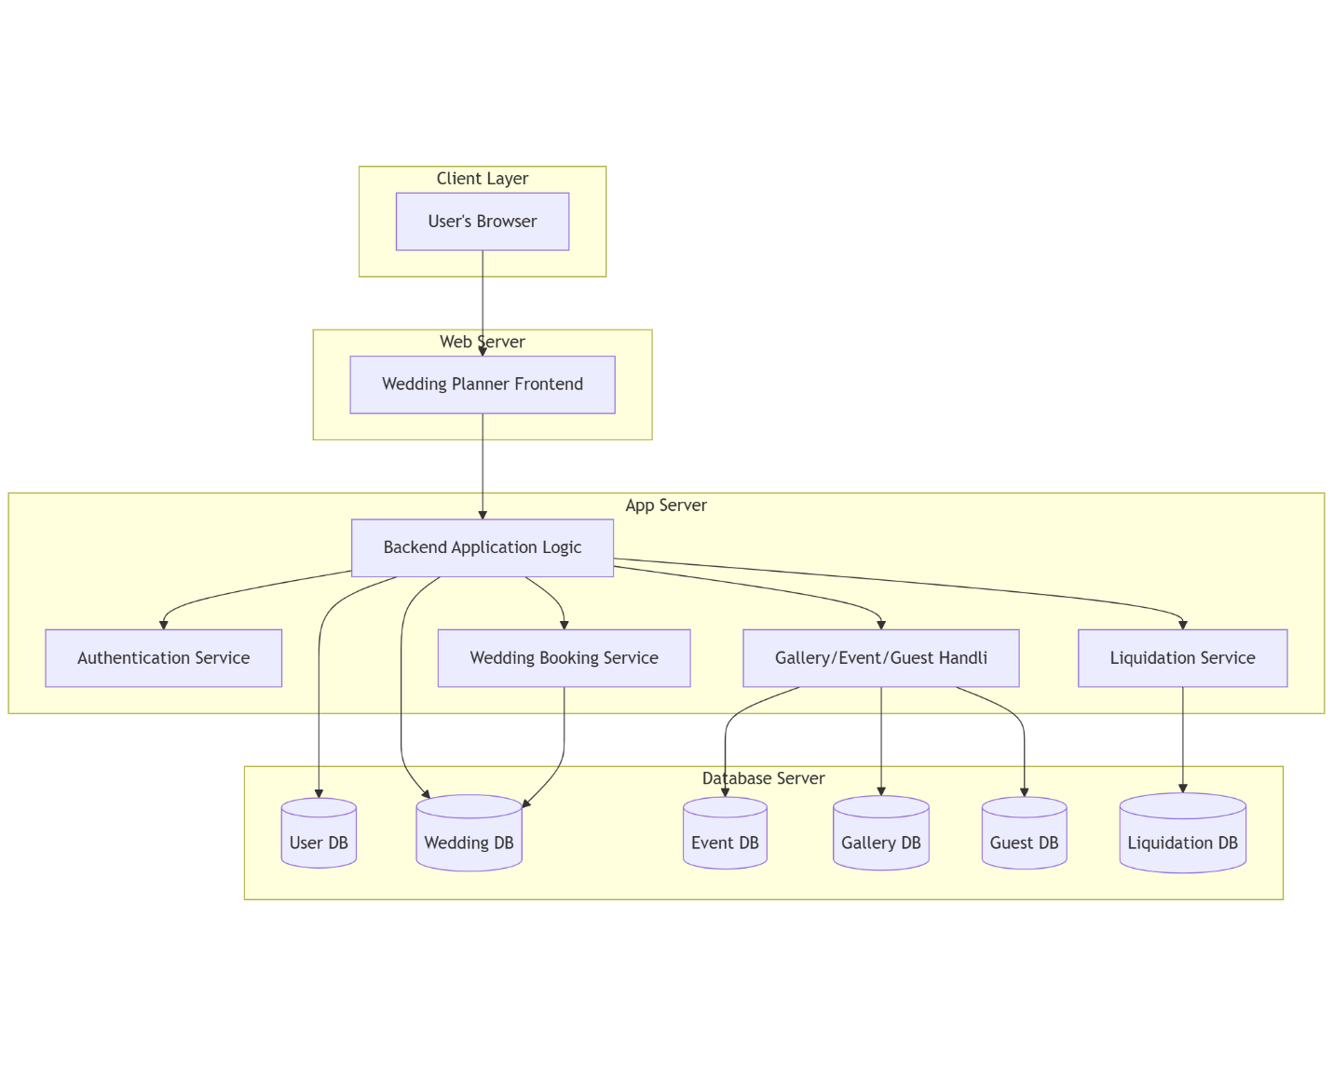

Data Flow Diagrams (DFD)
You need 2 levels:
- Level 0 (Context Diagram): Overall system interaction

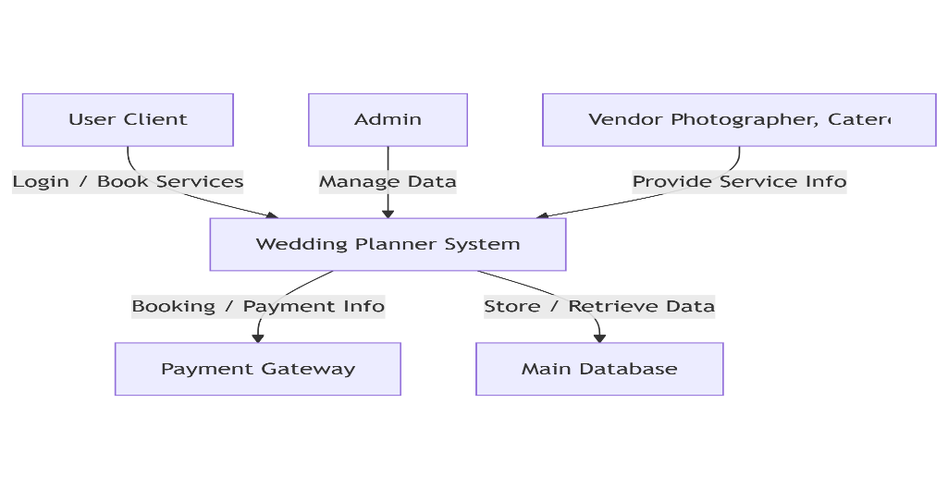
- Level 1: Break down major processes (e.g., vendor booking, payment)
